FOR IMMEDIATE RELEASE
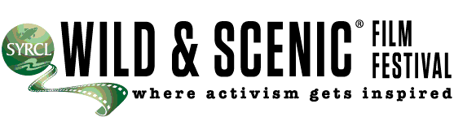

March 2012
CONTACT: AGATA SULCZYNSKI, 415.516.4972

Admission: Adults $8.00 in Advance; $10.00 Door
Students $ 5.00 in Advance, $6.00 Door
Date: March 24, 2012
Location: Black Bart Playhouse, 580 S Algiers Rd, Murphys, California 95247, 209 728-8842

The Wild & Scenic Film Festival opens the 2012 season with amazing films about the Sierras and beyond.

Ebbetts Pass Forest Watch opens the 2012 Wild & Scenic Film Festival on Tour Saturday, March 24 2012, 6:00 PM at Black Bart Playhouse in Murphys. Films range in topic from the very local Mokelumne River dam project to life in Bhutan where the government uses the Happiness Index to make national decisions. The following feature films will be shown:

About the Hard Life of Barn Swallow (Suitsupaasukese raskest elust)
The life of a Barn Swallow is not easy. Everything gets mixed up on the way back home from Africa, bigger birds are pesky, ghastly shadows from previous centuries annoyingly stalky, the clay is all gone and the barn locked at night.

Chintis Lundgren | 2011 | 5 min. | Estonia
Among Giants
As clearcutting continues to ravage California’s coastal redwood region, Farmer, an environmental activist, decides to tree sit to defend the McKay Tract, near Eureka. AMONG GIANTS begins three years into the McKay tree-sit. Stuck on his tiny platform a hundred feet up in the ancient redwood canopy, Farmer must battle the elements and avoid isolation as he fights for a sustainable future. In August 2011, Green Diamond Resource Company was granted on extension on their plan to clearcut the McKay Tract. Farmer’s dedication to protect the grove of old-growth redwoods and endangered species is now more important than ever.
Chris Cresci, Sam Price-Waldman | 2011 | 14 min. | USA | www.amonggiantsfilm.com
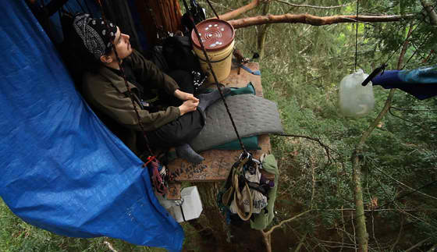
Bhutan: the Land of the Naked Crane
“Bhutan: Land of the Black-necked Crane” takes viewers on an exotic Journey to the small Buddhist kingdom high in the Himalayan mountains. See how a benevolent king promotes Gross Domestic Happiness for his citizens while fostering respect for the environment and natural resources. Travel with George Archibald co-founder of the International Crane Foundation to see the rare and endangered Black-necked Cranes.
Greg Pope and Rhett Turner | 2011 | 16 min. | USA
Craziest Idea, The
2011 was an historic year for rivers. The two dam removal projects that began as “crazy ideas” 30 years ago kicked off this year on the Elwha and White Salmon Rivers in Washington. These dam removal projects are the largest in history and represent a turning point in the effort to restore freeflowing rivers for salmon, recreation and culture. The climactic moment of the year was the explosive breach of 125 foot tall Condit Dam on the White Salmon, captured using video and timelapse photography techniques.

Andy Maser | 7 min. | USA
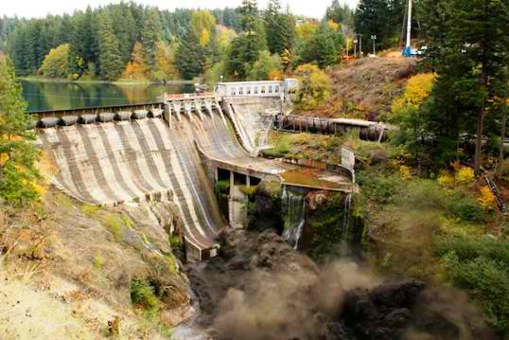
eel water rock man
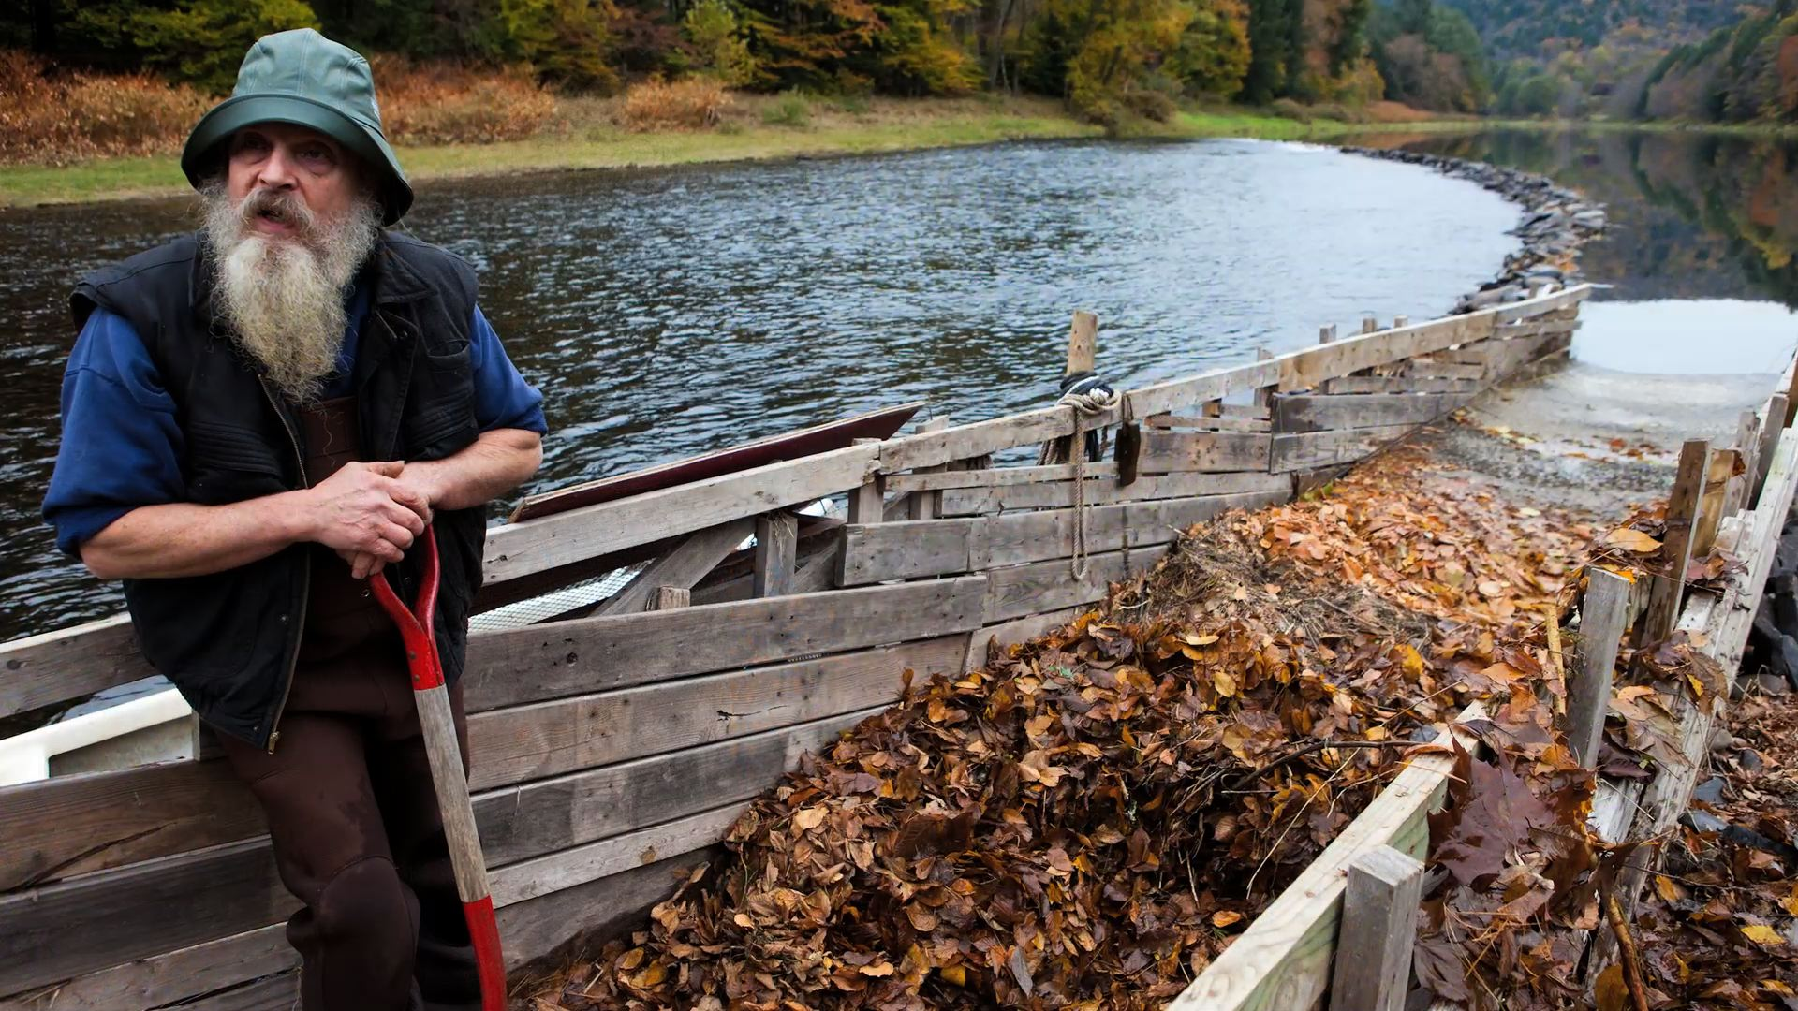
A short documentary vignette celebrating nature’s cycles, contentedness, and the last man on the east coast who still fishes for eels using an ancient stone weir. Narrated by artist and author, James Prosek.
Hal Clifford,Jason Houston | 2010 | 6 min. | USA | www.orionmagazine.org/index.php/audio-video/item/orion_original_video_eel_water_rock_man/
Kadoma
After more than a decade exploring Central Africa, Hendri Coetzee is a modern legend of African exploration. Solo on the Congo River in 2009, Hendri received an email from American expedition kayaker Ben Stookesberry. “It would be ludicrous,” Hendri said, “to take an American who you don’t know, and who has never been to Africa, into its very heart.” But a year later, he did just that.
Ben’s long-time kayaking partner, Chris Korbulic, joined the group as Hendri led the way from the Nile overland through Rwanda in order to kayak into the heart of the Congo on a previously unnavigated waterway, the Lukuga River. Seven weeks into the expedition, deep in the DRC, tragedy strikes.
On this ultimately tragic expedition, Hendri’s own words will always ring true: “Some of the things that we’re about to witness are so intense and horrible that they should stop the show; but they don’t. People still laugh and dance. Yes the bad things happen, but so do the good things, the amazing things, and the show goes on.”
Ben Stookesberry | 2011 | 44 min. | USA | cleah2ofilms.cm rescue.org

A Liter of Light | Columbia College | November 3, 2012
The film documents a foundation’s project to light up a poor neighborhood through the efforts of a local man who works for them. He becomes a beacon of hope to his community when he installs hundreds of solar-powered light bulbs in his neighbor’s houses. The clever device is made from old plastic soda bottles filled with water and bleach. Many of the homeowners can barely afford electricity and because their houses stand so close to each other, they don’t really get much daylight. With a little bleach, water and good will, their days are now much, much brighter.
Nick Santiago and Mike Talampas | 2011 | 2 min. | The Philippines | www.aliteroflight.org

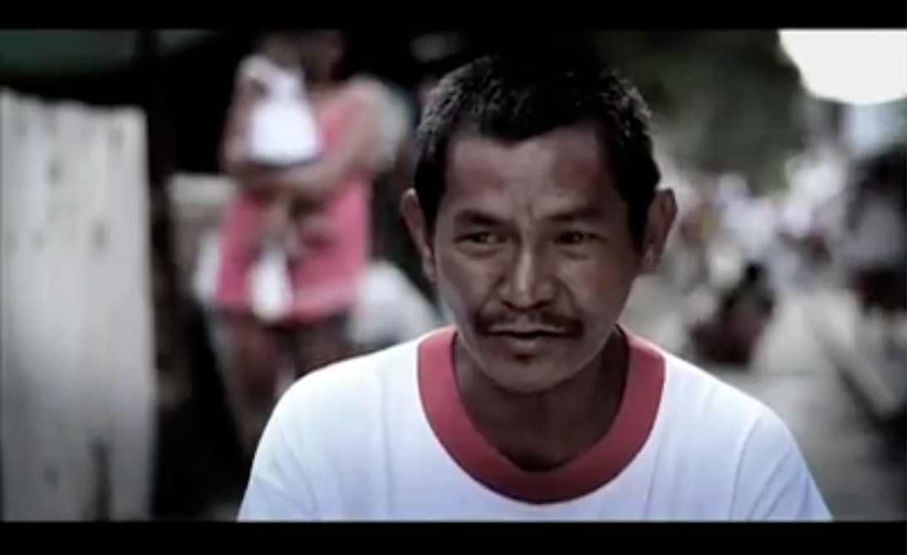
Marion Stoddart
This is the parallel journey of two characters: one a young woman discouraged at her future as a suburban housewife, the other a river — once beautiful and teeming with wildlife — now a hopeless, toxic sludge pit. Chronicling an important episode in U.S. environmental history, this inspirational story examines the human side of acclaimed environmental pioneer Marion Stoddart who proved that with vision and commitment, an “ordinary” person can accomplish extraordinary things.
Susan Edwards and Dorie Clark | 2010 | 30 min. | USA
workof1000.org www.moenviron.org www.rivernetwork.org/ www.americanrivers.org/about-us/
Mokelumne River: Wild and Scenic
This film highlights issues on the Mokelumne River including a proposed new Dam expansion that will flood critical habitat and unnecessarily destroy more river. From its headwaters in the high Sierra to the San Joaquin Delta, The Mokelumne River is a shining gem of nature. A National Wild and Scenic River Designation will ensure this precious resource is protected for future generations of fish, wildlife and people by preventing new dams and diversions on more than 37 miles of free-flowing river.
Mike E. Wier | 2010 | 10 min. | USA
burlproductions.com www.foothillconservancy.org CalTrout.org TUCalifornia.org OARS.com
The Towers of Ennedi
Follow climbers Mark Synnott, Alex Honnold and James Pearson as they travel across the roadless, windswept deserts of northeastern Chad. Basing their expedition on nothing more than a few photographs and rumors of a promised land with countless unclimbed sandstone towers, Mark’s insatiable thirst for adventure and first ascents leads the small crew deep into the spectacular landscape of the Ennedi desert. In their search for unclimbed sandstone towers, the team finds much more than climbing in this film about risk and the arc of a climber’s career.
Camp 4 Collective | 2011 | 13 min. | USA | camp4collective.com
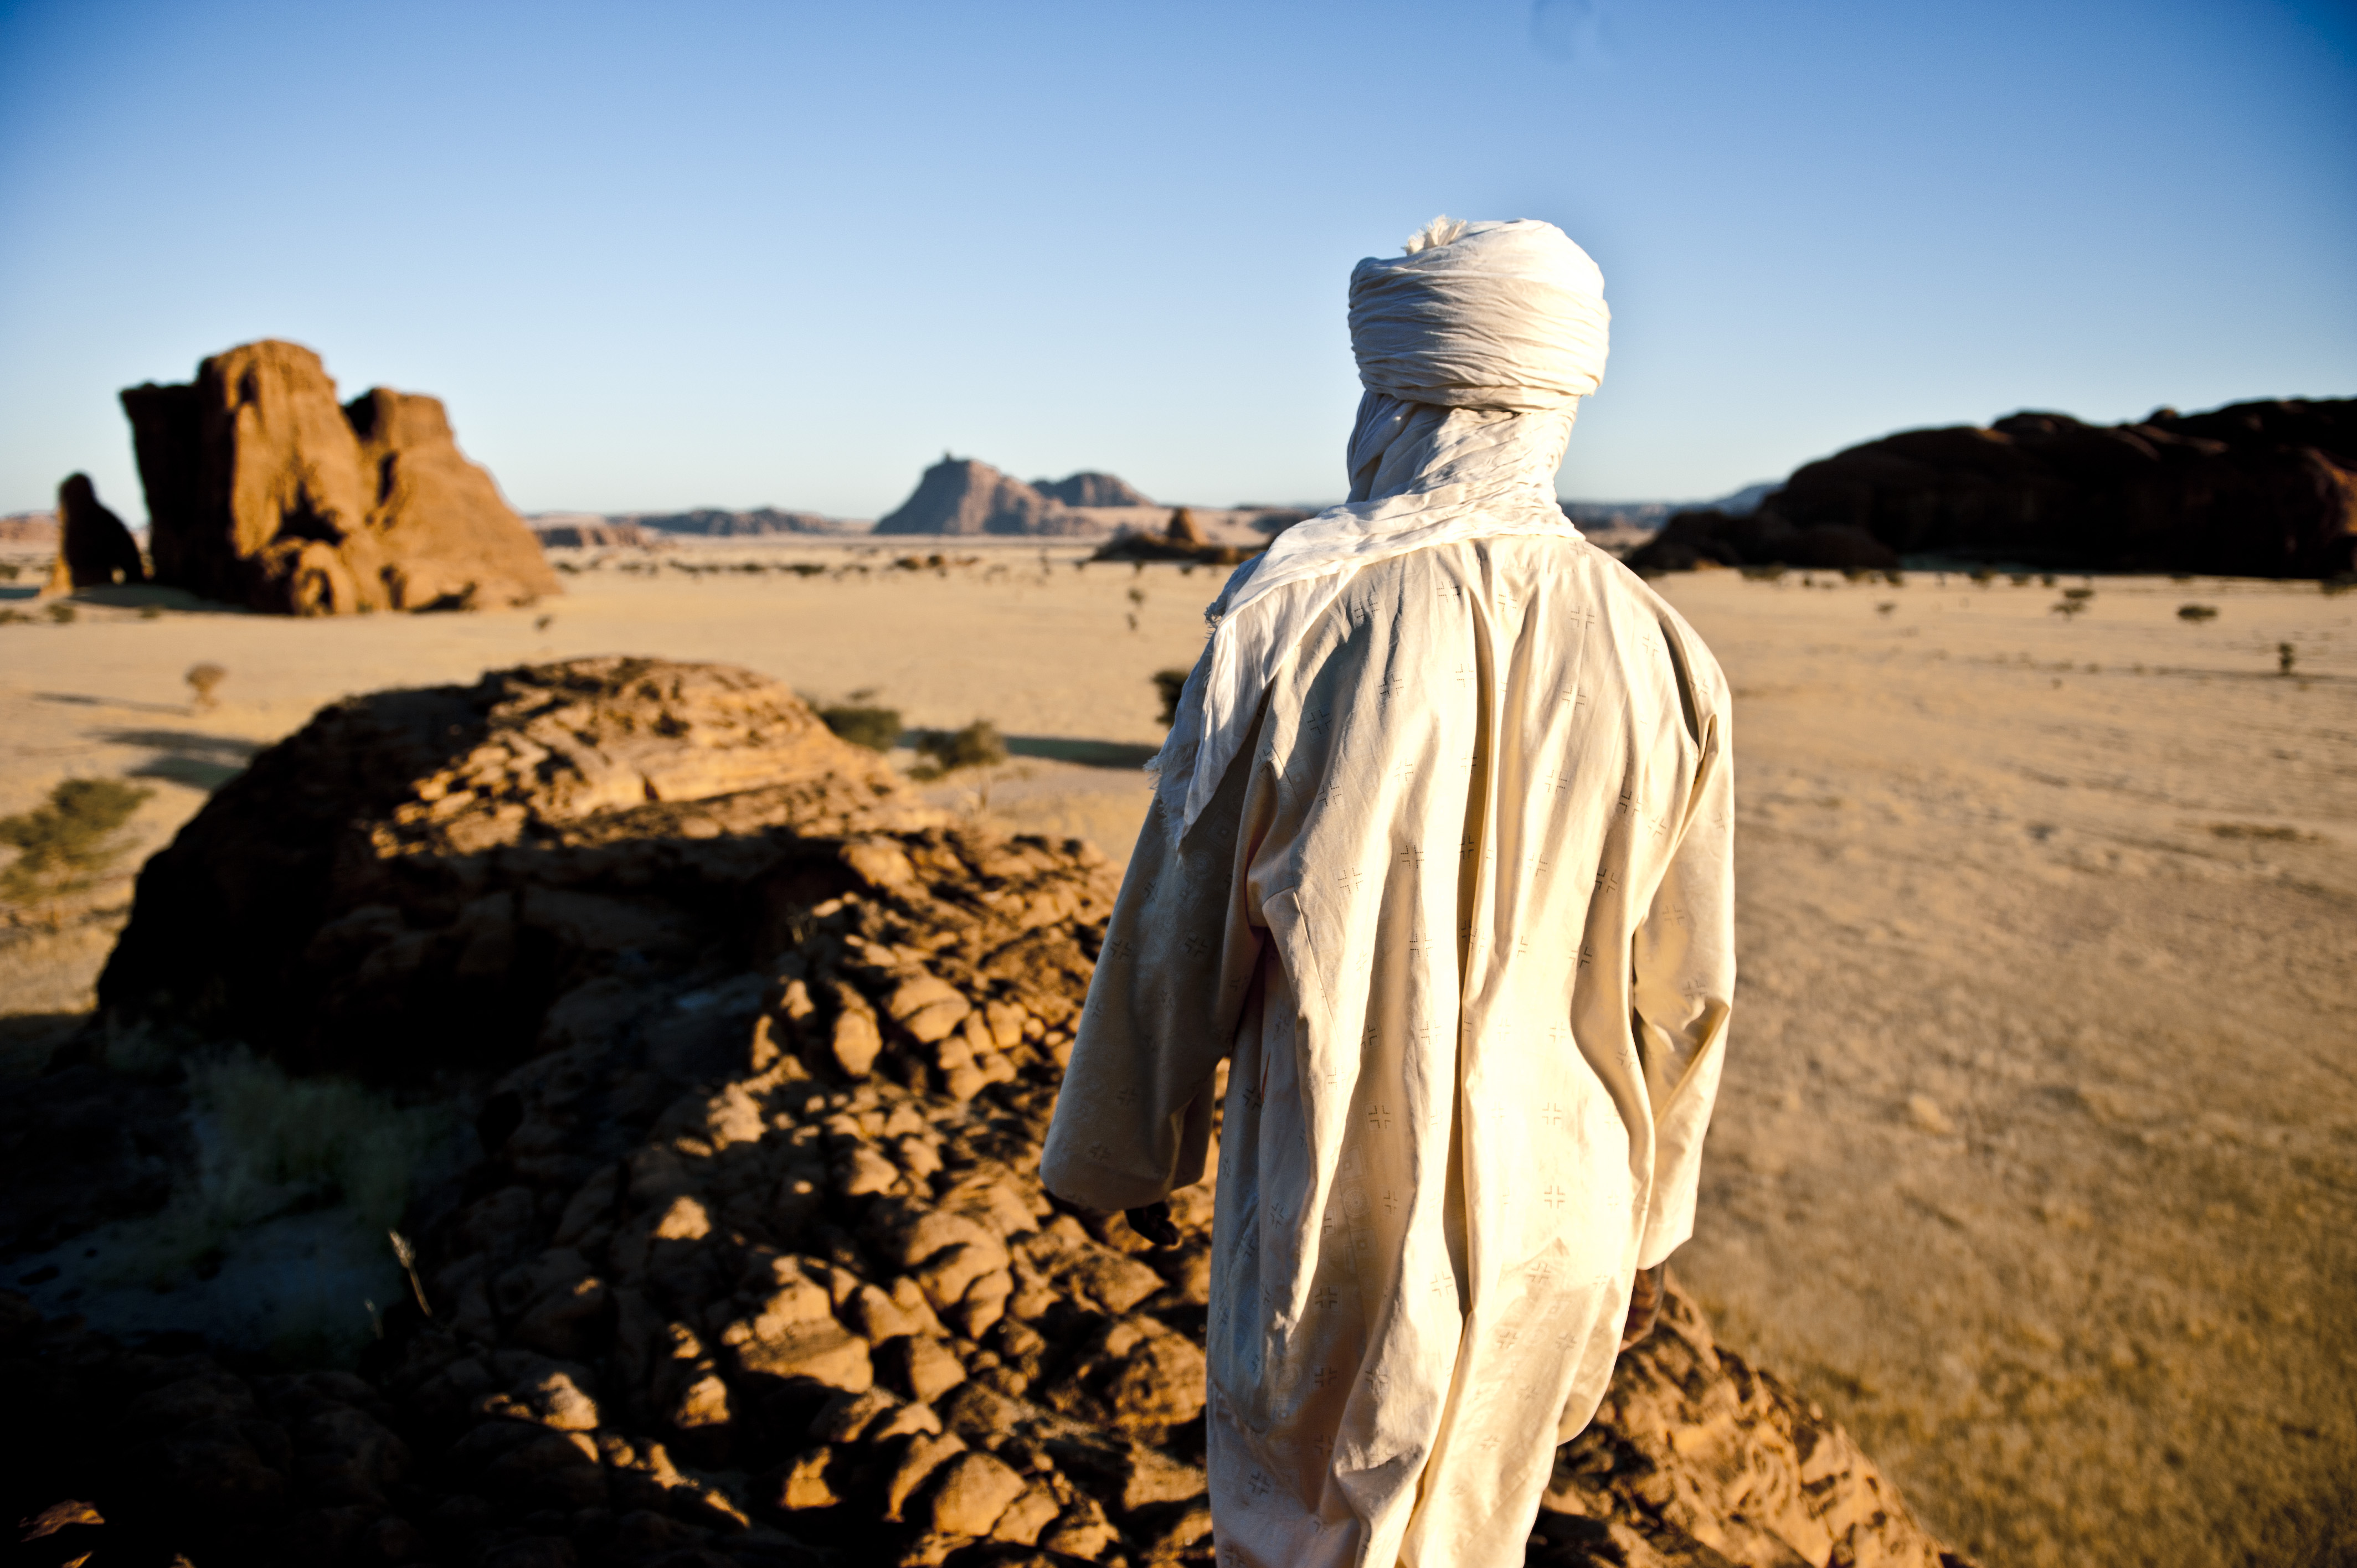

Ebbetts Pass Forest Watch, Arnold is proud to be the local host of the Wild & Scenic Environmental Film Festival on Tour for the eighth consecutive year. Check our website, www.sierrafilmfest.org for a schedule of upcoming films. EPFW promotes responsible, sustainable timber harvest practices through public education, legal action, and coordination with other conservation groups.

Schedule
DOORS OPEN 5:30 PM
6:00 PM | Welcome and Introduction
6:07 PM | About the Hard Life of a Barn Swallow (Suitsupaasukese raskest elust)
6:19 PM | Among Giants
6:25 PM | Craziest Idea, The
6:33 PM | eel water rock man
6:40 PM | Mokelumne River: Wild and Scenic
6:51 PM | Marin Stoddart: The Work of 1000
7:22 PM | Intermission
8:00 PM | A Liter of Light
8:03 PM | Bhutan: the Land of the Naked Crane
8:20 PM | The Towers of Ennedi
8:34 PM | Kadoma
9:40 PM | Closing

Additional film still photos can be downloaded at sierrafilmfest.org/press.html

